My Process of Organ Sound Synthesis
4 October 2007

This document describes the process that I use to generate ranks of virtual organ pipe sounds. The process is rather complex and, lest I forget the details myself, I will attempt to provide sufficient detail so that a computer literate person could use my C-programs to generate new sounds.

The word “new” is probably not a good description because I am really attempting to mimic real organ pipe sounds to the extent humanly possible. Hence, I start by using a digital recording of a real pipe organ sound. The recorded sound needs to start with complete silence and should be held for at least one second. Only one note must be played at a time; otherwise, one must attempt to identify the separate note sounds with a spectrum analysis and carefully remove one note component with notch filtering. This is difficult to do and is best avoided. I then dissect the recorded waveform with a wavelet transform so that I can use the transform data as a template to generate notes, with a similar timbre, over the scope of the keyboard. Arpeggio sound clips of many organ pipes can be found at
http://www.organstops.org/MainFrameN.html
My Morlet_probe program uses a continuous Morlet wavelet transform as a tunable bandpass filter. This program is discussed in detail in the companion document titled “The Morlet Wavelet Transform.” One first does a spectrum analysis of the waveform to be analyzed to determine the discrete frequencies that characterize the recorded note. These frequencies will henceforth be called “partials” in accord with similar nomenclature in related technical literature. I use Adobe Audition 1.5 software for the spectral analysis. Organ pipe sounds usually consist of a fundamental frequency (the lowest frequency) and higher harmonics that are integer multiples of the fundamental. If there are other components present, they are likely to be contaminants and should, in most cases, be removed by notch filtering (Adobe Audition) before being processed by Morlet_probe. On the other hand, since the Morlet_probe processing is essentially equivalent to passing the waveform to be analyzed through a comb of narrowband filters, any features of the waveform with frequencies different from the comb filters should be ignored.

A list of frequencies is generated as a text file as input for the Morlet_probe program. The sound sample to be analyzed (pipe organ sound) is usually in the form of a .wav file. This needs to be converted to a .txt file for processing and this step can be accomplished using Adobe Audition software.

On completing execution, Morlet probe maps out a time history of data points for the amplitude and phase for each partial frequency specified as input data. The amplitude and phase data can be used to regenerate the original note as well as all the other notes needed to create a rank of virtual pipes via frequency shifting of the partial frequencies. When you use the phase data, take note of the following information. The list of frequencies used for Morlet_probe are usually determined by reading them from a spectrum analysis of the sample waveform. However, remember that the spectral lines are collected in “bins” related to the size of the Fourier transform. Consequently, there will be some error in the frequencies that are determined by this process. If you use the phase data from the Morlet_probe to transform back in to the time domain, you must correct the probing frequency list to be exactly harmonically related and in-tune for the note being processed. Otherwise, there will be out-of-tuneness and possible dissonance in the resulting note synthesis process.

The phase data that are output from Morlet_probe are discontinuous because of the properties of the arctan function. I have another program called Continuous_phase.cpp that removes the offsets and yields continuous phase data.

The envelope data are captured in a separate file and named something like ampl_1, ampl_2, etc. The user can specify the names to be used before running Morlet_probe. Each file has sample points every 1/44,100 sec. The files are long because one second of data will consist of 44,100 points. For purposes of synthesis, the envelopes are over-specified. Many data points can be thrown away without losing a good description of the envelopes. I actually compress the file by a factor of 20:1 in subsequent steps of processing prior to the synthesis process.

Additional steps need to be performed to fully process the envelope data. These steps will be discussed below.

Filtering. I highly recommend looking at a graphical presentation of the envelopes produced by Morlet_probe. This is easily done by the following steps (assumes a PC
Windows environment):

1. Double click on an envelope text file (e.g., ampl_1.txt). This will open the text file.
2. Do ctrl-a to select all the data and then ctrl-c to copy all the data.
3. Open a blank spread sheet in Excel and do ctrl-v in one cell at the top of any column. This will copy the entire file of data into a column in Excel.
4. Select the entire column. Click on the graphing icon. Select chart-type “line” and any sub-chart type that you like. Then select “NEXT” multiple times until you can save the chart as a new sheet. Repeat this process for each envelope.

The process above is a quick way to view the envelope data. Only 32,000 data points will be plotted but this is quite adequate to see the general nature of the data.

I use my program called Smoothing_filter.cpp when filtering is desired. Sometimes I use the output of Morlet_probe without filtering; however, there are occasions when some envelopes show some oscillation and it is best to remove them in the amplitude data and absolutely essential to remove them from the phase data (see the section titled “Using the Phase Data”). More discussion on the causes of oscillation is given in “The Morlet Wavelet Transform.”

Smoothing_filter.cpp averages each data point with N points below and N points above, where I normally set N = 500.
Pnew(i) =(delta)⁻¹Σ_{j1}^{j2} P(j)old
j1 = i-N; j2 = i+N;
delta =2*N;

where “i” is the index of the sample point, “j” is the index of the displaced sample in the summation, and the summation is carried out over j = j1 to j2. At the start and end of the file to be processed, there are too few data points to conduct this average properly. This is adjusted by the following process:
j1=j-N;
if (j1<0) j1=0;
j2=j+N;
if (j2 > numpts-1) j2=numpts-1; (in C you count from 0, not 1)
delta=j2-j1;
where numpts is the number of data points in the file to be smoothed.

Smoothing_filter.cpp allows the user to specify the names of the input files to be processed and the names of the output files, which should be different to avoid overwriting the original input files. Note: sometimes two successive passes through this filter are necessary to remove large oscillations.

Clamping. Because of the width of Gaussian envelope in the original Morlet_probe processing, there is “droop” in the resulting envelope amplitudes at the beginning and ending of the envelope files. The droop is equivalent to the response of Morlet_probe to an impulse or step function in the envelope modulation of the partial under consideration and is frequency dependent as discussed in detail in the companion document “The Morlet Wavelet Transform.” As far as I know, there is nothing that can be done to avoid the droop at the beginning of the file or in response to a transient; however, this will probably be comparable to the natural rise time of the partial being analyzed. The droop at the end of the file is the result of “running out of data” in the wavelet processing. It is highly desirable in this situation to clamp the amplitude of each envelope to a constant value prior to the droop. If you do not do this, the resulting notes that are produced in the synthesis will have distorted envelopes (for the higher pitch notes) near the end of the waveform. The effect occurs most prominently at the higher-pitch notes because of the time scale contraction that I intentionally introduce to time-shrink the envelope data to achieve a faster waveform rise time as the pitch of the notes increase.

The clamping is done using another post-processing program called Clamp_1.cpp. Clamping also facilitates “looping” in a later stage of processing when I build the final sf2 sound font used in jOrgan. In order to achieve a “noiseless” loop, the waveform being looped must have periodic or repetitive features. If the partial frequencies are harmonic (i.e., exact integer multiples of the fundamental) and the amplitudes of each partial are steady, then the resultant waveform will be periodic and will loop nicely. If the amplitudes of the partials vary only slightly, one can still usually do looping satisfactorily. If you do the looping with Vienna, it is usually essential to do the looping near the end of the note waveform where the amplitudes of the partials have been clamped; otherwise, you may not get a noise-free loop. However, if you use the Seemless Looper software tool (available for purchase over the internet), good loops can usually be made in the non-clamped area. This is primarily because Seemless Looper has a “cross fade” feature that modifies the waveform in the loop transition area to reduce the audible glitches that would otherwise exist. The Clamp_1 program allows the user to specify the clamp point for each envelope. I determine the clamp point in the following way:

Refer back to the Excel charts that you produced when looking at the output data from Morlet_probe. Find the point near the end of the file where the data begins to fall off or “droop” because of the effect previously described. Excel will tell you the point value if you position the curser on the envelope at that point. Record that point for each envelope for use as input to the clamping program. I don’t always clamp at the same point for all envelope files. Sometimes the envelope has significant amplitude variations and I sometimes like to pick a point that looks like an approximate average of the previous excursions. If you are not using Seemless Looper to set the loop (to enable continuous playing of the note) you may want to clamp much earlier, say about 0.75 sec assuming that you have synthesized about 1.5 sec samples. The reason for this statement is that if you use a tool like Vienna, which does not have a cross-fade feature, you may be able to get successful loops only in the clamped region and you need to preserve enough clamped sample length to achieve adequate waveform periodicity. Also be aware that a waveform that has significant amplitude dynamics has a much more interesting sound than the sterile sound that you get from static amplitudes and clamped loops.

Clamp_1 allows the user to specify the names of the input files to be processed and the names of the output files, which should be different to avoid overwriting the original input files.

Add_Chiff. The term “chiff” relates to a higher harmonic transient that is often heard in flute-like pipes when the pipe first begins to speak. Chiff adds color, interest, and clarity to the initial sounding of the pipe. If the recorded pipe sound contains chiff the Morlet_probe program will capture this effect in the envelopes (usually in the 7th harmonic partial). Sometimes the original sound contains no chiff or too little chiff and the user desires to add chiff. My Add_Chiff.cpp program will add a parabolically-symmetric chiff to an envelope as another post-processing step. Usually the chiff is added to the envelope for the 7th-harmonic; however, if the pipe sound has no seventh harmonic, the 5th harmonic envelope can also be used. The program allows the user to specify which envelope is being modified with chiff. Again, the user can and should specify a different name for the output file when this processing is done. Add_Chiff.cpp requires the following input data:

- Starting and ending data points for the chiff insertion. Again, use the Excel charts to determine these points. Usually you want the chiff transient to rise and fall before the envelope for the fundamental rises to its initial maximum. For example, you might expect to insert a chiff transient between .02 and .08 seconds.
- Value of the amplitude of the existing envelope where the chiff is to begin.
- Value of the amplitude of the existing envelope where the added inverted-parabolic chiff is expected to blend back in to the original envelope.
- A chiff multiplier factor, which determines the final amplitude of the chiff maximum (=chiff_multiplier * envelope_amplitude_at_steady_state). I generally use a chiff multiplier between 5.0 and 10.0. Don’t worry if the result is too large or too small because you can modify the chiff amplitude in the final synthesis program.
Compress_files. As stated previously, the envelope data contain many more data points than are really needed to adequately specify the time evolution of the envelopes. My program Compress_envelopes.cpp compresses the envelope files by 20:1 by throwing away 19 out of every 20 data points. It is very feasible to carry out a reconstructive synthesis using the over-specified envelopes and I have programs to do this. However, by reducing the envelope file size (and hence the processing time) we have the opportunity to add desirable additional processing features into the synthesis. These features are included in the synthesis programs that will be discussed at the end of this document.

Before compression, the envelope files were time referenced to a sampling rate of 44,100 samples per second. After compression we need a new time reference. I produce this reference in the following way.

- Generate a serial text file that contains time data every 1/44,000 of a second.
- Compress this file using Compress_envelopes.cpp and output a compressed time file called “time.txt.” (Interpolation routines use time.txt with the compressed envelope files in later synthesis processing.)
- New time.txt files can be generated by the user, but it is acceptable to re-use the time.txt file for other compressed envelopes.

Chop_file_end. The processes of compressing the file moves all the desired data point to the front end of the file and leaves the remaining worthless data in the tail of the file. The Chop_file_end program removes the worthless data and shortens the file size by a factor of about 20. The user needs to specify the length of the compressed data files that needs to be preserved. For example, if all of the compressed envelope files are static by sample point 1330, then the user specifies 1330 as the length of the file to be preserved by Chop_envelopes_1.cpp. Note that the time.txt file should also be processed by Chop_envelopes_1.cpp to a establish a corresponding chopped time reference. Caution! The user must insure the first data point in the chopped time reference file reads “0.0” If not, re-define it as 0.0. This is necessary for the interpolation programs to execute properly. I’ll try to remember to force this change in the code so the user does not have to do it.

At this point, all necessary processing of envelope files has been completed. We are ready to do reconstructive synthesis to produce a full rank of virtual pipes. I have several programs to do this. The first program that we will discuss bases the synthesis for the complete rank of pipes on one set of envelopes. All notes produced will have an identical timbre, except for very high-pitch notes where the higher frequency partials exceed the Nyquist frequency limit for a sampling rate of 44,100 (and also exceed the range of human hearing) and are, consequently, excluded in the synthesis. A second synthesis program will also be discussed in which the synthesis can be based on two sets of envelopes. This is useful when it is desirable to migrate to a timbre that is more pleasing to the ear at the highest frequencies.

Regurgitation. It is desirable to summarize the steps given above for the processing involved in the synthesis process. I will outline them again in this section. Also, after going through this process many times, I have found that a slightly different ordering of steps is more efficient.
- Acquire the sound file to be analyzed and convert it to a .txt file.
- Analyze the sound file to determine the frequencies to be processed by Morlet_probe. If you intend to use the phase data from Morlet_probe, correct the frequency list to be exactly harmonically related and in tune for the note being analyzed. The frequency correction is not necessary if you don’t use the phase data.
- Take a quick look at the envelope data produced by Morlet_probe to see if filtering needs to be done. If so, run the data through LP_filter2.cpp once or twice (if necessary) to smooth the envelopes.
- If this is the first time you have ever gone through this process, you need to create a text file with time increments that increase by 1/44100 per second. This file should extend to about 1.5 seconds.
- Run the phase data files produced by Morlet_probe through the Continuous_phase.cpp program to produce continuous phase data files.
- Compress the time file and envelope files using Compress_envelopes.cpp. There is no real advantage to compressing the phase files and I do not do it.
- Chop off the redundant end of the compressed files using Chop_envelopes_1.cpp. The compressed time file will then have time increments that are 20 times larger.
- Determine the clamp points. Note that I have shoved clamping to later in the process than previously described. The reason is that after the envelope files have been compressed and end-chopped, the file size in then small enough so that its complete extent can be viewed in an excel chart and the appropriate point to set the clamp point can be read off the chart very exactly via the curser dialog. If you look at the non compressed files, Excel cannot display the entire chart unless you force the display to begin midway through the file.
- Clamp the ends of the envelope files using Clamp_1.cpp.

You now have all the information needed to run synthesis programs that do not use the phase data. Although the best sound syntheses are produced by using information from the phase data, this introduces more complexity that I will reserve for later after the section titled “Using the Phase Data.” Here I would like to keep things a bit simpler and discuss syntheses that ignore phase data by using exact (or calculated) frequencies in the Fourier series used in the synthesis process. This type of synthesis can be conducted by using the program ELAsynthesis_300.cpp, which is described below. This information includes:
  - The processed envelope files.
  - A integer text file that lists the harmonic numbers associated with each frequency that was processed (e.g., 1,2,3,6,8,10,14,18, ………).
  - The compressed time file.
  - The following parameter values:
nsamp number of samples in the envelope and time files
num_partials number of partial freqs in the synthesis
freq0 freq at which original sample was taken

Single_timbre_synthesis. This synthesis is based on my program ELAsynthesis_300.cpp. An important feature of this synthesis program, which is not available in a synthesis directly from the non-compressed envelope files, is the ability to intentionally contract the time scale as a function of frequency. This is done for the following reason. The rise-time for the envelopes (and consequently the resultant sound) is frequency dependent in the real world. Flute pipes at low frequencies have slower rise times than flute pipes at high frequencies. However, if we don’t build this feature into the synthesis, synthesized notes will have identical rise-times at all frequencies and the rise-time will be the same as that of the original sound sample processed by Morlet_probe. The time distortion is achieved by generating a temporary time scale, called tmod[i], where

tmod[i] = t[i]*(.25*sqrt(freq0/ff) + .03)/.28 (This is what I used originally)
Recently, I’ve felt that this compresses the envelope detail excessively at the higher pitches, so I’ve switched to the following………..
tmod[i] = t[i]*(freq0/ff)^{1/4}

and “i” is the sample point index, “ff” is the note frequency, and freq0 is a reference frequency specified by the user. Usually, freq0 will be the fundamental frequency of the note analyzed by Morlet_probe. The equation above is an empirical relationship that I developed and can be easily changed by the user to something else. It is easy to see that when ff is smaller than freq0, the increments in time advance more slowly. When ff = freq0, tmod[i] and t[i] are identical. Since the synthesis has to produce a waveform with time increments of 1/44,100 per second, the tmod[] time base is used in an interpolation equation with the envelope data to produce the output waveform. It is important to note that trying to implement this feature with non-compressed envelopes would be excessively costly with respect to processing time. The tmod[] time-base contraction forces interpolation to be used and the processing cost is far less with the compressed data files.

The synthesis program is set up to produce note groups of size two. I let jOrgan use the sf2 font capability to use frequency interpolation to produce the other note in the note group. For example, the synthesized note group D4 will produce notes D4 and D4# when keyed in jOrgan. A note-group size of two reduces sound-font memory requirements by a factor of two and does not result in audible artifacts to the user. The program is set up to produce note groups in the range of C1 toA9# (a total of 54 note groups), where C4 is middle C. The user can synthesize fewer note groups by specifying a start_note number and a stop_note number.

The program also allows the user to throw one or more of the partials out of tune (sharp or flat) in the attack phase of the note. The frequency offset gradually diminishes to zero at a time “time_offset_end” specified by the user. If I use this feature ( I usually do not), I set “time_offset_end” to about 0.4 to 0.5 seconds. The offset values are read in by a user-supplied f_offsets.txt file. Set “time_offset_end” to 0.0 to suppress this feature.

There is also a provision to add frequency dependence to the magnitude of the chiff. Typically I find that the chiff amplitude has to be larger at low frequencies and smaller at mid to high frequencies. If this provision is not activated, the chiff amplitude stays the same, independent of frequency. The chiff amplitude can also be increased or decreased by a static factor. All this is achieved by the code segment

end=chiff_end;
temp = pow(10.0,log10(chiff_ref_freq/ff)/4.0);
for (j = 0; j<=jend; j++) y[j] = y[j]*temp*chiff_mult;
(the expression for “temp” is empirical and can be changed by the user )

where “chiff_end” (user specified) is the “compressed” time index where the chiff transient ends, “chiff_ref_freq” (user specified) is the scaling reference frequency, “chiff_mult” is the static multiplication factor, and “pow” is the POWER function. Note that the bypass = 0 option (see user inputs below) must be selected to be able to activate the chiff_mult static multiplication factor as well as the frequency-dependent scaling.

ELAsynthesis_300.cpp requires the following user inputs:

- nsamp – number of samples (data points) in the envelope and time arrays (must be the same for all data files).
- num_partials – the number of partials or envelopes used in the synthesis.
- freq0 – the reference frequency for the tmod[] time base distortion.
- start_note – the number of the note group where the synthesis begins (1 = C1, 7 = C2, etc…)
- stop_note – the number of the note group where the synthesis ends (36 = A6#, 42 = A7#, 48 = A8#, 54 = A9#, etc….)
- time_offset_end – explained above.
- bypass – “1” bypasses the chiff frequency-dependent processing; “0” invokes the processing. See additional explanation above.
- chiff_index – specifies which envelope (partial index) contains the chiff transient
- chiff_end – explained above.
- chiff_ref_freq – explained above. The larger the value, the greater the chiff enhancement at low frequencies.
- chiff_mult – static multiplier for the chiff

Two_sample Synthesis. My 2-sample_synthesis_303.cpp program allows the use of two sets of envelopes over the scope of the rank of virtual pipes to be synthesized. The idea here is to use one set of envelopes derived from a waveform with timbre that sounds good for the lower-pitch notes and another set of envelopes derived from a waveform with timbre that sounds better at higher-pitch notes. The user specifies a transition region (say C4 to C5) where the synthesized waveform gradually changes from that produced by the first set of envelopes to that produced by the second set of envelopes. Linear interpolation between the two sets of envelopes is used to invoke the transition.

All the previous features of ELAsynthesis_300.cpp still apply; however, the use of two samples adds a complication with respect to providing the distorted tmod[] time base as discussed previously. Here each set of envelopes will have its own characteristic rise time and we will usually not want to use the same reference frequency to scale the time distortion. So in this program the user defines freq1 (reference frequency for the first set of envelopes) and freq2 (reference frequency for the second set of envelopes). Two distorted time bases are created, tmod1[] and tmod2[], where the amplitude data of the first set are referenced to tmod1[] and the amplitude data of the second set are referenced to tmod2[]. However, we now need to establish a common time base to which both sets of envelope data can be referenced. To do this, we revert to the initial t[] time sequence for a common time base and use linear interpolation within each set of envelope amplitudes and its corresponding tmod[] time base to produce new envelope amplitudes appropriate for the common time base. Still another interpolation is used in the transition region to generate a common merged-envelope data set for the 2-sample synthesis. Finally, this merged set of envelope data is used with the common time base t[] in another interpolation in time to produce the output waveform sampled at a rate of 44,100 samples per second.

Both synthesis programs develop the final waveform for each note group by serially computing the waveform for each partial and then sequentially adding the partial waveforms together. Since each partial is processed separately, memory requirements in the synthesis are minimized by processing only one envelope data file at a time. Each envelope is re-read as many times as the number of note groups to be produced. Hence, the cost of memory efficiency is the increased time associated with repetitive file reading. However, execution time is still very reasonable.

The inputs required by 2-sample_synthesis_303.cpp are:

- nsamp – number of samples (data points) in the envelope and time arrays (must be the same for all data files).
- num_partials – the number of partials or envelopes used in the synthesis.
- freq1 – the reference frequency for the tmod1[] time base distortion.
- freq2 – the reference frequency for the tmod2[] time base distortion.
- start_note – the number of the note group where the synthesis begins (1 = C1, 7 = C2, etc…)
- stop_note – the number of the note group where the synthesis ends (36 = A6#, 42 = A7#, 48 = A8#, 54 = A9#, etc….)
- time_offset_end – explained above.
- bypass – “1” bypasses the chiff frequency-dependent processing; “0” invokes the processing. See additional explanation above.
- chiff_index – specifies which envelope (partial index) contains the chiff transient
- chiff1_end – array index in compressed time scale where the chiff ends in the 1st data set
- chiff2_end – array index in compressed time scale where the chiff ends in the 2nd data set
- chiff1_ref_freq – explained above. Reference frequency for frequency-dependent chiff processing for 1st data set.
- chiff2_ref_freq – explained above. Reference frequency for frequency-dependent chiff processing for 2nd data set.
- chiff1_mult – static multiplier for the chiff in 1st data set
- chiff2_mult – static multiplier for the chiff in 2nd data set

Some of these parameters can only be optimized by trial and error, i.e., by conducting the synthesis and then listening to the synthesized notes by using Adobe Audition or any other sound file editor that will open a text file and interpret it as a digitized sound wave. The sound editor should then be used to convert the file to a 16-bit monaural wave file for subsequent importing into Vienna 2.3 to do looping and other processing necessary to convert the wave files into an sf2 sound font to be used by jOrgan. Vienna only accepts wave files that are 16-bits and sampled at 44,100 samples per second. I have developed other documentation that discusses the use of Vienna, so I will not repeat that here.

Non-constant Timbre. With the exception of the 2-sample_synthesis_303.cpp program, all note synthesis has to this point been done with a single timbre specification that is propagated through all note pitches. With the 2-sample synthesis two different timbres are specified and there is a gradual transition from one to the other over the span of one to one and one-half octaves.
It is well known (http://www.pykett.org.uk/how_the_flue_pipe_speaks.htm) that real organ pipes do not preserve a constant timbre across a rank of pipes. The reasons for this are well stated by Pykett and will not be repeated here. The objective of changing the timbre is to gradually reduce the relative amplitudes of the higher harmonics in the tone waveform at higher pitches to prevent the sound from becoming shrill or piercing (this problem has indeed been evident in my constant timbre syntheses.) In real organ pipes this is done by increasing the “scale” of the pipe as the pitch of the pipe increases. Scale is defined as the ratio of the pipe diameter to its length. Organ builders developed their own proprietary scaling rules, which varied somewhat to accommodate the acoustics of the cathedral. One scaling rule quoted by Pykett is that the pipe width is “haved” every 17th note while the pipe length is halved every 12th note (every octave). The relationship of pipe width with frequency for this scaling rule is computed below.
W = Wo/(2^{n/17}), where W is the pipe width (or diameter) at frequency “f” and Wo is the pipe width at some reference frequency “fo”. “n” is the note number (12 notes (semitones) to the octave).
L=Lo/(2^{n/12}), where L is the pipe length at frequency “f” and Lo is the pipe length at the reference frequency “fo”.
f = fo * 2^{n/12}
or, n = 12 * log₂(f/fo)
The scale of the pipe “S” is
S = W/L = (Wo/Lo) * (2^{n/12})/(2^{n/17}) = So * 2^{5n/(12*17)}
Substituting the expression for n in terms of f/fo and doing the necessary mathematical manipulation, we get
S = So * (f/fo)^{5/17}
Hence, the pipe scale changes as the 5/17-th root of f/fo. The corresponding decibel change in the ratio of S/So would be a logarithmic function of the ratio of f/fo. Hence, we might take a wild guess that the decibel changes in the strengths of the spectral components of the pipes might also change as a logarithmic function of f/fo. The following analysis of some real data seems to support this hypothesis.
I have attempted to analyze the change in relative strength of spectral components of a set of Principal pipes for which I have some data. Unfortunately, while a definite trend toward a pattern in timbre change is apparent, the data are so affected by standing wave interference caused by the acoustics of the cathedral where they were recorded that all I can say is that the data are not inconsistent with a scaling rule that follows a dependency on ln(f/fo).
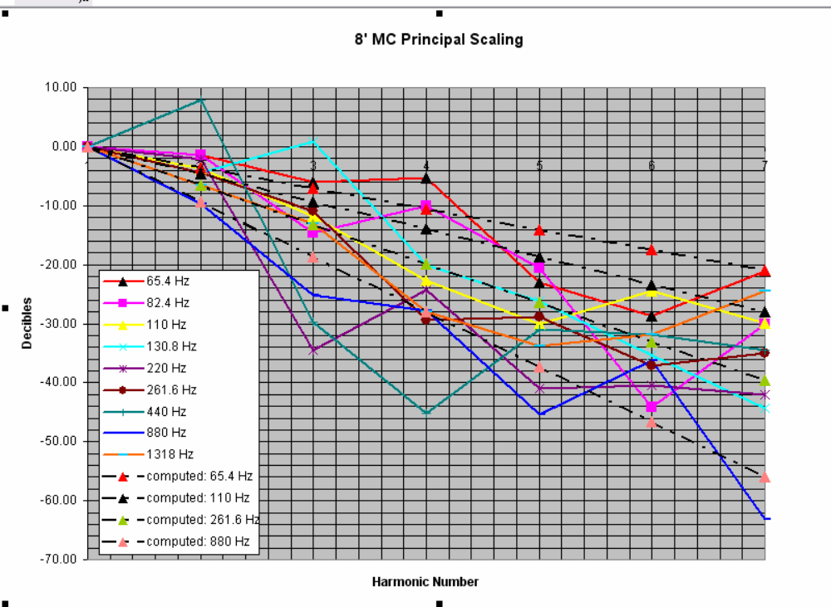

The chart above shows the ratio of the harmonics spectral strengths in dB relative to the fundamental as a function of harmonic number from 1 – 7. The data are connected with colored lines as an artifice to help track the progression with harmonic number for each
different note frequency. This artifice is necessary because of the huge scatter in the data. Data are shown for nine different fundamental frequencies.
A scaling law for these data was estimated to be

Y(dB) = -3.5 * (H-1) * (1 + .64 * ln(f/fo)), where H is the harmonic number and Y(dB) is the relative strength of the harmonic component to the fundamental at fundamental note frequency “f”. Here fo is the frequency of the lowest fundamental in the series analyzed (65.4 Hz).

If we would like to change the timbre specification in our synthesis according to such a scaling rule, we really only want to determine the change in spectral power from its timbre specification at fo as the note frequency changes with frequency “f”. This change is just

Delta_Y(dB) = -3.5 * 0.64 *(H-1) * ln(f/fo) , or

Delta_Y(dB) = -2.24 * (H-1) * ln(f/fo)

A new synthesis program, ELAsynthesis_400.cpp, uses a generalization of this expression as a scaling rule to modify the timbre during the synthesis of the musical note waveforms. The multiplier “-2.24” is replaced by a changeable input parameter in the configuration file for the synthesis. By proper selection of this “slope” parameter, a more pleasing timbre is achieved at higher note pitches while preserving the original timbre at a lower pitch specified at fo. The nice thing about this is that it is easy to generate multiple syntheses with different timbre migrations using the original set of envelopes which establish the original timbre. ELAsynthesis_400 retains all the previous features of ELAsyntheis_300.

Synthesis without Morlet_probe decomposition. Good recordings of pipe organ sounds are not readily available in may cases. It is possible to be inventive and create the envelopes.

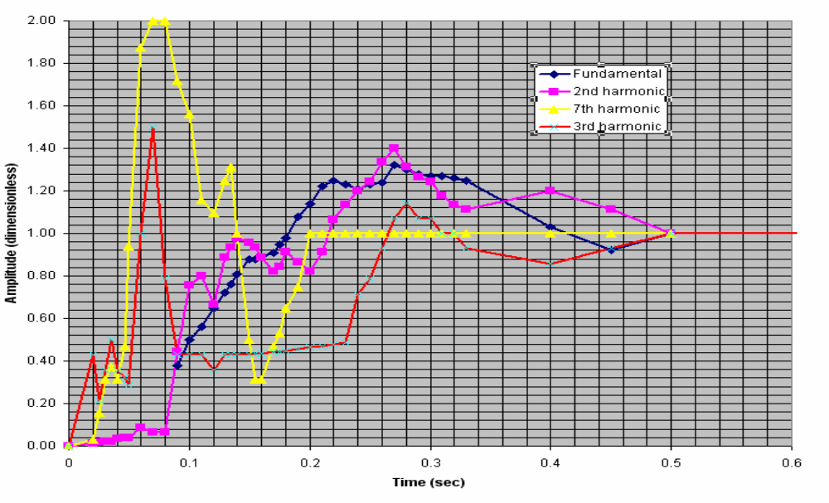

The example shown in the chart was created by drawing envelopes on a piece of graph paper and then transferring the amplitudes as a function of time to a spread sheet. Amplitude data must be estimated and recorded for all envelopes at the same set of time points. The time points need not be uniformly spaced but a text file of time values for which amplitude measurements were made must be created. The sequencing of the time entries must match the sequencing of the amplitude values.

You will notice that all envelopes eventually mature at a value of 1.0, meaning that the envelopes themselves do not carry absolute value. It is not necessary to stabilize at a constant value of 1.0; the envelopes can (and probably should) show some gradual undulations for more interesting sound quality in the synthesized waveforms. The powers associated with each harmonic component are specified in dB by a separate file called Hpowers.txt. I usually set the strongest component at 0.0 dB and the rest at negative values. For this type of synthesis I use the program ELA_synthesis_C100. In most respects the program functions similar to ELA_synthesis_300.

Required inputs for ELA_synthesis_300 are:
"myconfig.txt";
nsamp: number of sample points in the envelopes (y_profiles) and time files
lharm: number of harmonics being processed
freq0: reference frequency for the time scale distortion used to modify waveform risetime with frequency.
maxtime: maximum length of note waveform in seconds (usually <1.0).
maxnotes: (usually 54)
bypass (1=yes, 0=no)
The program has a provision for modifying the “chiff” transient amplitude of the 7th harmonic component (if it has one) as a function of frequency. It raises the amplitude of the chiff below reference frequency fo and reduces it above fo according to an empirical scaling rule. The peak in the yellow envelope curve shown above represents the envelope of a chiff transient. The chiff modification is by passed by setting bypass = integer 1
creftime
The chiff modification is limited to the time interval between t=0 and t=creftime. Creftime should be chosen as the time for which the chiff peak is just a bit beyond the maximum (e.g., beyond the maximum of the yellow peak above).
cendtime
Pick a time reference point on the original y7profile at which point we want to force the chiff exaggeration back down to the steady-state level of 1.0. Call this "cendtime" and input this value. The program tries to smooth the transition region between creftime and cendtime.

"notes.txt"
An input text file that provides the names of the notes for output. E.g.,
Flute_C1.txt
Flute_D1.txt
Flute_E1.txt
Flute_F#1.txt
Flute_G#1.txt
Flute_A#1.txt
Flute_C2.txt
Flute_D2.txt
Flute_E2.txt
Flute_F#2.txt
Flute_G#2.txt
Flute_A#2.txt
Etc……….
"Hpowers.txt";
A file that specifies the power of each spectral component in dB. E.g., for a waveform with a fundamental and 6 harmonics (lharm = 7), the file would look like:
-15.0
0.0
-10.0
-40.0
-15.0
-40.0
-50.0

"tprofile.txt" The time file for the synthesis.
"y1profile.txt" The envelope for the fundamental.
"y2profile.txt" The envelope for the 2nd harmonic, etc…..
"y3profile.txt";
"y4profile.txt";
"y5profile.txt";
"y6profile.txt";
"y7profile.txt";
"y8profile.txt";
For convenience, the program assumes that all spectral components higher than the 8th harmonic have the same envelope profile as the 8th harmonic. However, the Hpowers specification will in general be different for these components.

Example of decomposition and re-synthesis. An example of the Morlet wavelet decomposition of a sample waveform and the re-synthesis of multiple note waveforms will now be presented. The waveform sample will be a C4 note that was extracted from a Krummhorn arpeggio sequence that was obtained at one of the sites accessible by the web link cited at the beginning of this document. In my referencing scheme C2 is the lowest key on the keyboard for an 8’ organ stop, C4 is middle C, etc. A 1.2 second sample of the time-domain waveform is shown below.

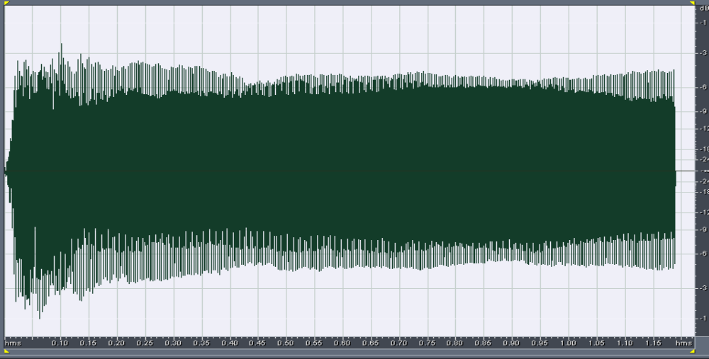

The corresponding frequency spectrum is shown next.

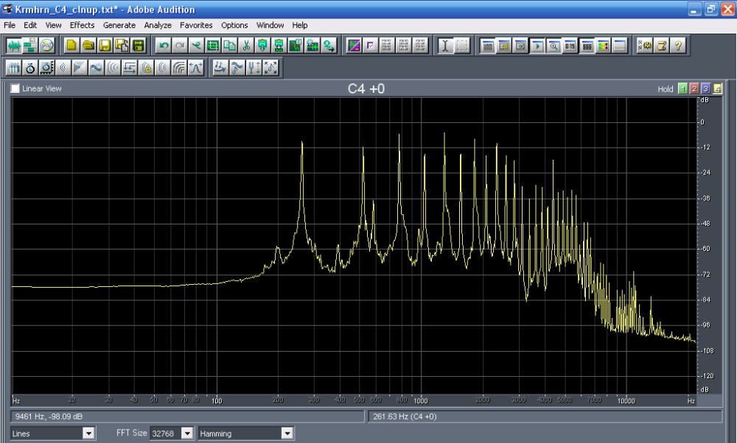

The frequencies and harmonic numbers for the significant spectral components are listed below. Components that are 60 dB below the maximum are not audible.

Krummhorn C4 sample spectrum

index Harmonic Frequency
number (Hz)

1 1 261.63
2 2 523.25
3 3 784.88
4 4 1046.50
5 5 1308.13
6 6 1569.75
7 7 1831.38
8 8 2093.00
9 9 2354.63
10 10 2616.25
11 11 2877.88
12 12 3139.50
13 13 3401.13
14 14 3662.76
15 15 3924.38
16 16 4186.01
17 17 4447.63
18 18 4709.26
19 19 4970.88
20 20 5232.51
21 21 5494.13
22 22 5755.76
23 24 6279.01
24 25 6540.63

This list of frequencies was used with Morlet_probe to map out the envelopes for each partial component. After filtering and compressing, the envelopes appear as shown below.

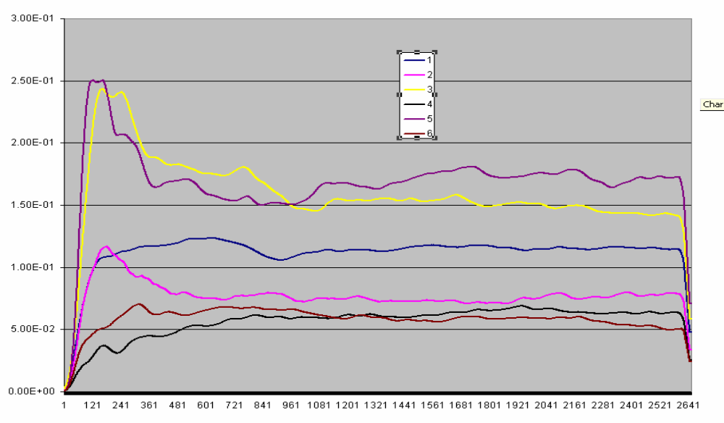

The figure above shows the envelopes for the first 6 partial components. The x-axis annotations are the data point indices. Time can be calculated by multiplying the index by .0004535 sec. The envelope length is 1.2 seconds. The next 6 partial envelopes are shown next.

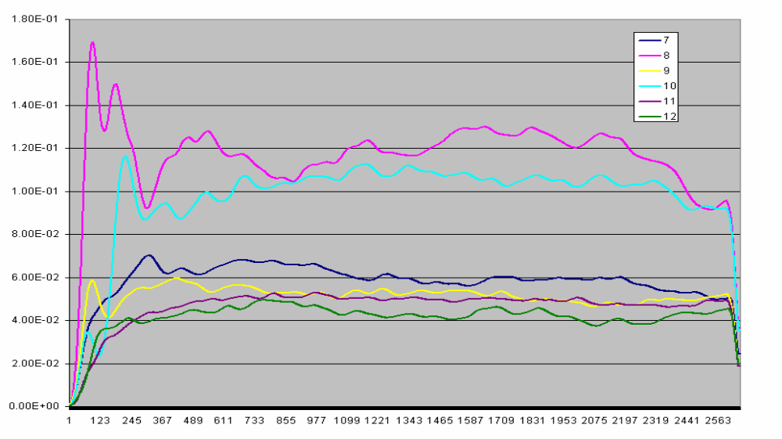

Although there are 24 envelopes for this decomposition, we will just show the first twelve.

The remaining 12 envelopes are not shown because, while they are significant, they don’t add much new to the current discussion. Since the envelopes have not been clamped yet, the droop in the envelope amplitudes is visible near the end of the envelope sequence. Prior to running a synthesis, the droop will be removed by clamping at the non-drooped value.

These data were then input to ELAsynthesis_300 to compute time-domain waveforms for all the notes necessary to fill an entire organ keyboard (five octaves). First we will show the synthesis of the C4 note and compare it to the original. The synthesized time-domain waveform is shown below.
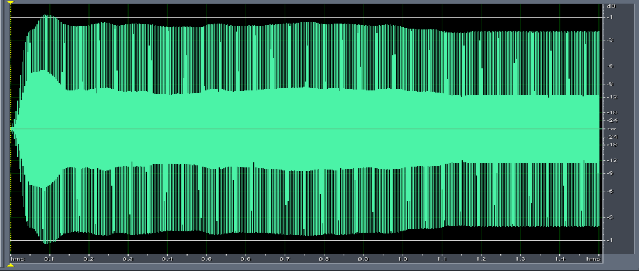

Here the synthesis has been carried out for 1.5 seconds. Beyond 1.2 seconds the effect of clamping the envelope amplitudes is evident because of the flatness of the wave train. Generally the appearance of the time-domain waveform is not very close to the original even though the actual sound is very close. This is attributable to the phase data. A good explanation follows in the section titled “Using the Phase Data.”

The spectra are in pretty close agreement as shown in the figure below. The red lines display the synthesized waveform spectrum and the yellow-green lines display the previous Krummhorn sample spectrum. The discrepancy in the number of spectral lines near the end is, of course, caused by the fact that we only synthesized the most significant 24 frequencies. It is also obvious that the spectra for the real sample have widened bases compared to the spectra of the synthesized note. Some insight into this is presented later in the section titled “Transient Partials.”

I performed four sets of syntheses for the Krummhorn envelope set. One synthesis retained a constant timbre for all note pitches (realizing of course that at the highest pitches, some of the high harmonics are lost (thrown out) because they exceed the Nyquist limit for a sampling rate of 44,100 per second. The other syntheses employed the timbre-scaling feature mention earlier using input slope parameters of 0.242, 0.726, and 2.178 for the generalized expression

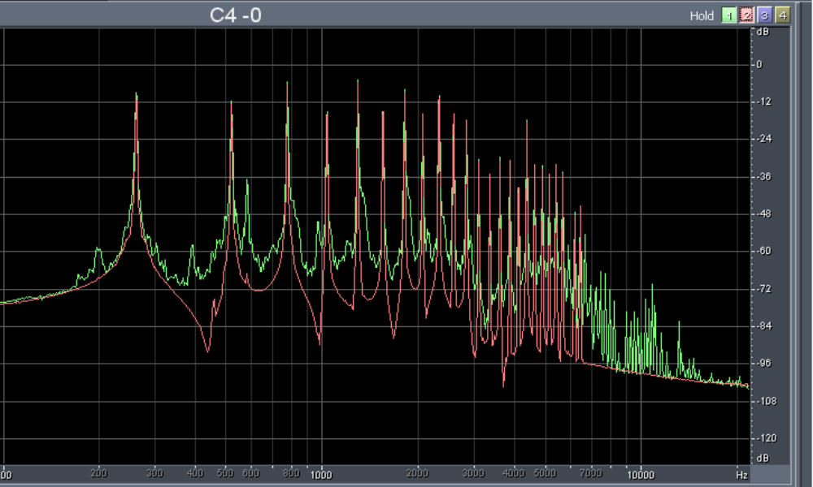

Delta_Y(dB) = -m * (H-1) * ln(f/fo), where m is the slope parameter.

The Adobe Audition spectrum analyzer was used to carefully measure the power ratio (in dB) for each harmonic component synthesized at slope “m” relative to power of the constant timbre synthesis (m=0) for the note C6, which is two octaves above the “pivot” point at note C4. These power ratios were identical to what would be computed by the equation above with f/fo = 4 and m = the values stated above. This is not surprising but it is a good check that the synthesis is doing what it is supposed to do. Hence, once can use the equation above to predict how the timbre will change in advance of doing the synthesis. This is advantageous if you have some idea of how the timbre should change. However, usually you don’t have that knowledge and you have to do a set of syntheses with different values of “m” and listen to the result. My limited experience so far seems to indicate that the optimum value for the slope “m” will be different for different types of sounds, e.g., different for flutes than for Krummhorn or Trumpet.

Lastly, I want to present a few pictures of the time-domain waveform for a few notes as they progress toward higher pitches. The principal reason for this display is to show how the risetime of the waveforms becomes faster at the higher pitches. This is done intentionally in the simulation by time-scale contraction for the envelope data by an empirical expression, which the user can change as a program code modification. The reason for this is that in real life, low-pitch pipes are slower to speak than high-pitched pipes. It is doubtful that my empirical expression matches the real pipe performance (which probably varies among different types of pipes, e.g., flutes, horns, strings, etc.), but some correction here is better than none at all. Note: The examples shown below were done for an previous empirical expression
tmod[i] = t[i]*(0.05*sqrt(freq0/ff) + 0.03)/0.08

and not the expression

tmod[i] = t[i]*(freq0/ff) + .03)^{z}, z = 0.25

that I am currently using. However, the example demonstrates the point adequately and it is not worth re-doing the pictures to correspond to the currently used scaling rule.

Although not readable in the pictures, the time scale is 0 to .17 sec. The C2 note takes approximately .14 to .15 sec to rise to maximum. The C3 note takes .11 sec, C4 about .085 sec, C5 about .067 sec, C6 about .055 sec, and C7 about .047 sec. With this scaling rule, the time scale is limited to a maximum compression of 0.375. The markedly different appearance of the C7 waveform probably is caused by the loss of several high frequency harmonics, which exceed the allowable Nyquist limit.

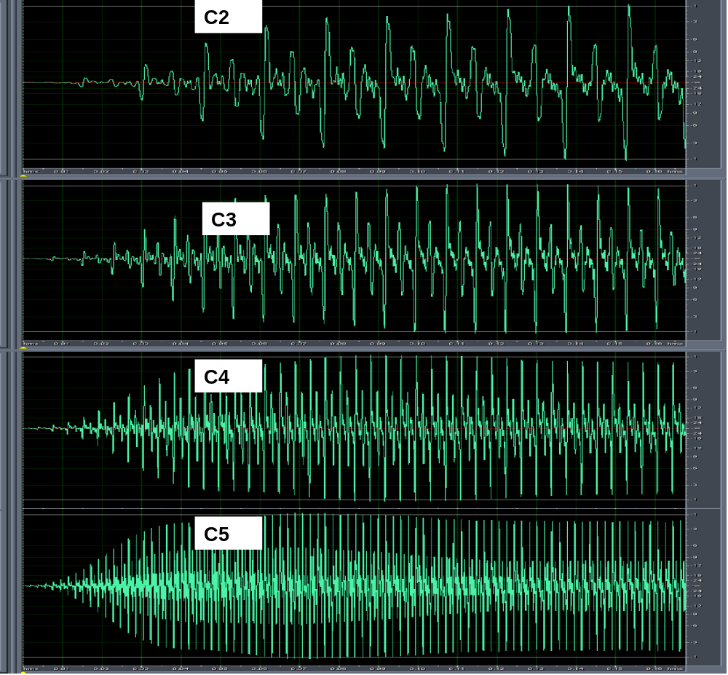

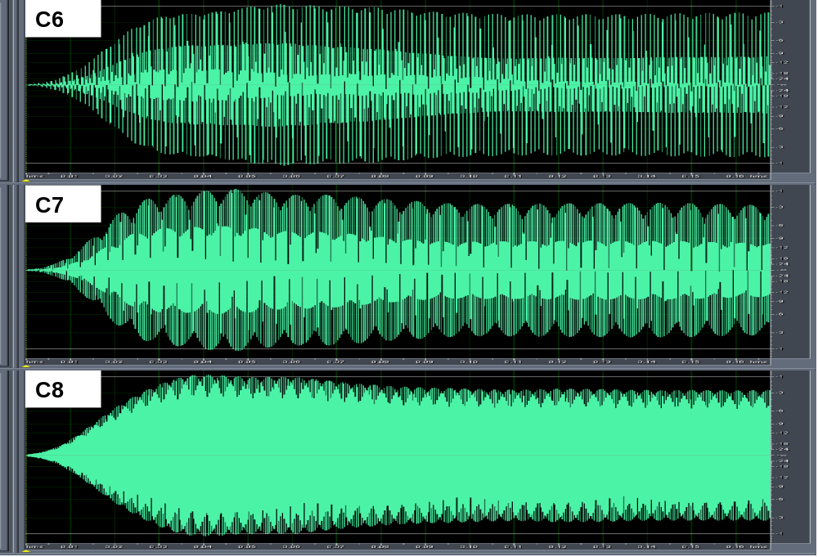

Using the Phase Data. For a period of time I was not sure whether using the phase data made a significant difference in the sound syntheses. Certainly, information is lost when the phase data are ignored. The “deciding moment” occurred when I tried to synthesize an E3 note from the same Krummhorn arpeggio sequence mentioned previously. The synthesis using calculated frequencies in place of the phase data produced a spectrum that very closely matched the amplitudes of the partials from the original Krummhorn E3 sound sample. However, the sound was significantly different and the time-domain of the waveform looked quite different from that of the original. No amount of adjusting the amplitudes of the envelopes made a significant difference in either the sound or the time-domain signatures. Then I did a synthesis that used the continuous phase data and “whallah!” the sound was a close match to the original and the time-domain signature was more comparable to the original. This clearly impressed on me that there is information in the phase data that need to be captured in the synthesis. This discovery then led to an investigation that led to some related discoveries.

The first thing that I did after this initial success was to attempt to produce a full rank of notes using the phase data. Here the frequencies in the Fourier expression sin (2*pi*freq*t) are replaced by sin(phase(t)*shift) where phase(t) are the continuous phase data and shift is a calculated multiplication factor, which depends on the ratio of the frequency of the partial under consideration to the frequency of that partial in the original sound sample. The result was quite satisfactory at note frequencies below the frequency of the reference note (E3) but distortion (as evident in the spectra) was evident at higher frequencies. The cause was traced to the fact that I had not filtered the continuous phase data. The non-filtered continuous phase data looked quite smooth and regular (almost a straight, sloped line as a function of time) when displayed for about 30,000 sample points in an Excel chart. However, at closer examination (by looking at an Excel chart over a range of just a few thousand points), small oscillations about the straight line average was evident. These oscillatory excursions become increasing significant at higher “shift multiplications” used to form higher frequency partials. This effect can be avoided by using the Smoothing filter (with N=500 to 1000) on the continuous phase data. Synthesis with the smoothed phased eliminated the distortion in the notes generated at pitches above the reference E3 note. However, there was now a slight glitch in the sound at the startup of the synthesized note. This was caused by a defect in the startup of the Smoothing_filter.cpp program; at that time I did not have the end-correction for “delta” in the filtering expression
Pnew(i) =(delta)⁻¹Σ_{j1}^{j2} P(j)old

that was discussed in the Filtering section above. This produced a curved deviation from the otherwise almost linear trend of the phase data. Even though the correction should remove this effect, the first N points will not be smoothed as well as points beyond the first N in the sequence. My approach to dealing with this problem was to fit the continuous phase data to a linear equation

p(t) = a + b * t

for each of the partials in the note. When determining the coefficients “a” and “b”, the first several thousand data points in the smoothed continuous phase data were ignored so that the startup glitch would be avoided. The synthesis program was then modified to accept the linear equation (with different values of “a” and “b” for each partial) instead of the actual phase data. This action produced a good synthesis and avoided the startup glitch mentioned above. Having done this, it became obvious that this approach should be identical to synthesizing using calculated frequencies in the Fourier expression

Y_{p}(t) = sin(2 * pi * f * t + a)

Where Y_{p}(t) is the waveform of the partial component (for constant unity amplitude) at frequency “f”. Sure enough, doing the synthesis this way produced similar results. Consequently, the most important part of the phase data are the intercepts (the phase shift at time equal to zero). The phase intercepts certainly play a role in how the waveforms of all the partials add up to form the resultant waveform. Different intercepts or phase offsets change the pattern of interference (constructive or destructive) in the resultant waveform. I wondered if there was a predictable pattern to the phase intercepts as a function of the frequency of the partial. The data are plotted in the chart below.
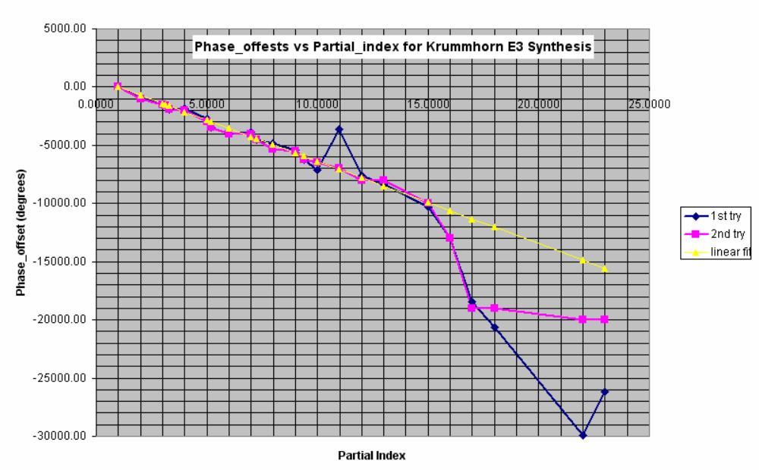

The partial_index is the equivalent to the harmonic number for partials that are not true harmonics, i.e., an integer multiple of the fundamental frequency. However, in this case, the partials are essentially harmonics. The data seem to follow a straight line trend until we get to large partial indicies. At this time, I’m not sure why this occurs. For one thing, there seems to be more error in the data at high partial indicies. The magenta and blue curves represent two different attempts to determine the intercepts experimentally. The blue trace used curve fitting to the data using Matlab. The magenta trace resulted from plotting the first 4000 points as an Excel chart and using a straight line projection of the data to the origin. Some phase data had a slight curvature (caused by a frequency change with time in the original partial) and this is probably the source the of intercept discrepancy in the two methods.

If one is creating a synthesis without a sound sample to mimic, one wonders whether the linear trend shown in the data above should be used to calculate phase intercepts instead of using zero-valued intercepts as has been done previously. Since we now understand that these phase intercepts affect the resultant time-domain waveform and, most importantly, the sound, this is an important issue.

In an effort to further understand the effect of phase intercepts a study was conducted. The first step was to further reduce the phase intercept data obtained from the Krummhorn E3 waveform by subtracting appropriate multiples of 360 degrees. Since the sine or cosine function is cyclic with phase increments of 360 degrees, nothing is changed by the subtraction process. The motivation for doing this is to reduce all the phase shifts to 360 degrees or less and then look to see if a linear or predictable trend still occurs. The result of this exercise is shown below.
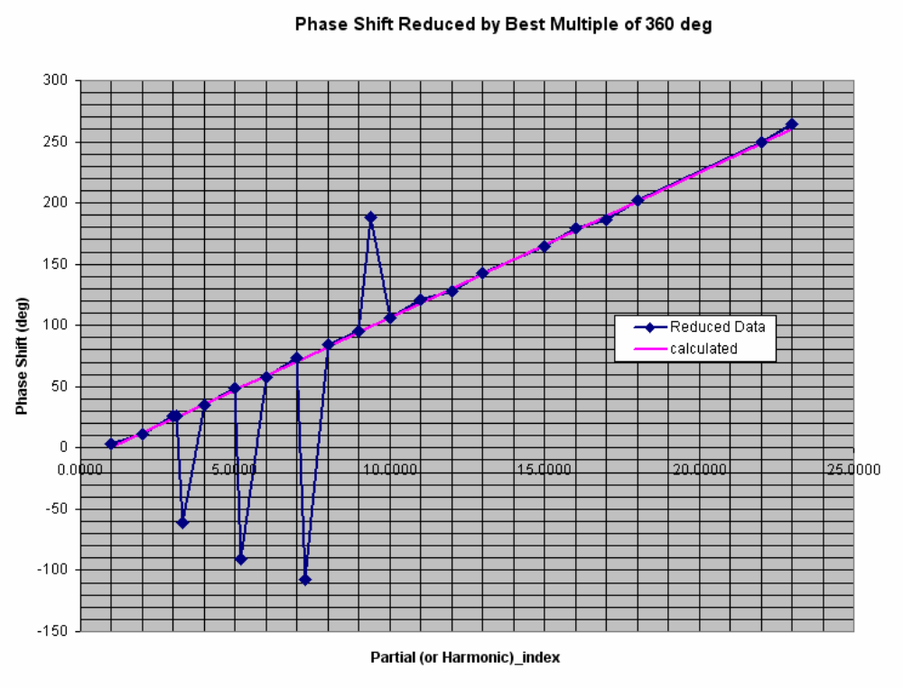

Several important things are evident in this plot.
- With the exception of four data points, the data fall on a straight line described by the equation

P_intercept = 11.82 * (PI – 1) degrees, where PI is the partial (or harmonic) index, which is measured along the x-axis.

- The last six data points, which looked to be in error in the previous display, are now in excellent agreement with the linear trend. Apparently, the data, as previously displayed, were just offset by one or two multiples of 360 degrees.

- The four data points that seem to be in error are for partials that are not true harmonics. This may be caused by trying to extract data (via Morlet_probe) at a frequency that is too close to a strong harmonic (inadequate discrimination between the two components).

The next step in the investigation, was to plot sine waves for a fundamental plus several harmonics and look at how these partials add to a resultant waveform in two cases:
- with zero phase intercepts
- with phase intercepts computed by the equation above.

The waveform summation was done for an example including all harmonics through the 7th using an Excel spreadsheet. The result is shown below.
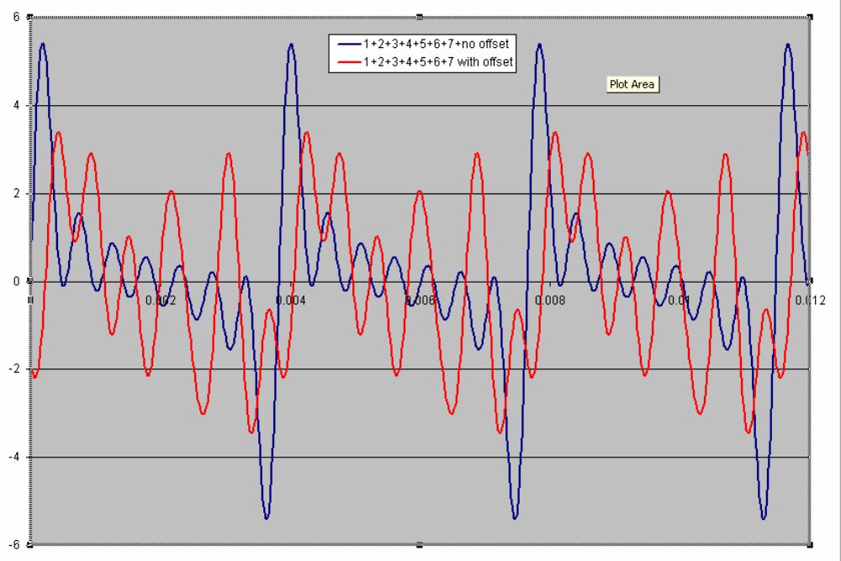

The blue curve represents the resultant waveform generated with zero phase intercepts. The red curve is the waveform that results with the intercepts computed by the linear fit to the Krummhorn E3 data. Note the significant compression of the envelope of the modulation for the waveform with non-zero phase intercepts compared to the case with zero phase intercepts. The audible consequence of this compression is to increase the volume of the higher frequency components compared to the fundamental and, indeed, this is what is observed with the time-domain pictures of the Krummhorn E3 note with and without using the phase intercept data.

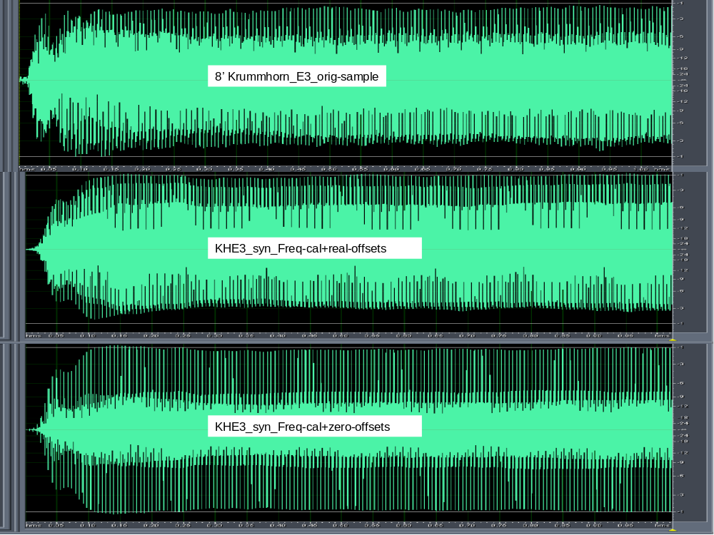

In these pictures, the dark band in the central portion of vertical extent represents the higher frequency content. Note how the synthesis with non-zero phase intercepts looks more comparable to the picture of the original Krummhorn sample than the synthesis with zero-valued intercepts.

My lesson learned from this investigation is that phase intercepts ought to always be included in the sound synthesis process. If there are no experimental data to draw from that would suggest a different relationship than what was found in the Krummhorn example, I will use the computed intercepts. Since the intercepts definitely affect the resultant sound, I believe that I’m more likely to be right using the computed intercepts than using zero-valued intercepts. Nearly all my syntheses to date have been done using zero-valued intercepts. I intend to redo several of these syntheses to see what change of sound occurs by including intercepts and whether it is more or less pleasing.

Transient partials. In the synthesis of the Krummhorn E3 sound, a very close match was obtained to the steady-state sound. However, there was something different in the early attack phase of the E3 sound sample. This effect disappeared after about 0.1 sec or somewhat earlier. An 8192-point spectrum analysis of the first 0.2 seconds of the E3 sound sample is shown below.

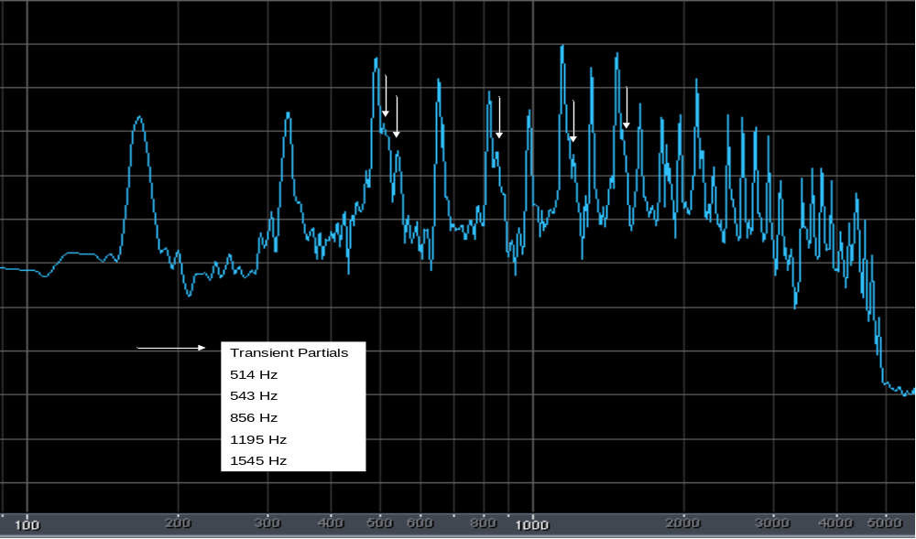

The major spectral peaks correspond to the fundamental frequency and its harmonics. However, it is evident that the width of the spectrum is somewhat extended toward the higher frequency side for the 3rd, 5th, 7th, 9th, and other higher odd-order harmonics. This spectral widening tends to diminish when the spectrum is taken over a longer time span and this is consistent with the concept that the non-harmonic partials that contribute to the spectral widening are short-lived. I attempted to model this effect by running Morlet_probe at the transient partial frequencies shown in the picture above. To keep things fairly simple, I ignored the smaller contributions above the 9th harmonic. I hoped that Morlet_probe would be able to separate the contributions of these estimated partials from the nearby harmonic components. The ouput of Morlet_probe did show a pronounced “blip” in the envelope amplitude in the (0, 0.1) second time interval. However, while the envelope amplitude did drop after the initial blip, it did not drop low enough to keep the effect from being seen beyond 0.1 sec. I assume that Morlet_probe is still picking up some contribution from the nearby harmonic component. At this point I was forced to depart from a pure scientific approach and try some “art.” I forced the envelope amplitude of each transient partial to quickly go to zero after the transient blip. Phase intercepts were also measured from the phase data for these partials. The five transient partials were then included in the synthesis. The result was, indeed, to produce a transient addition that sounded somewhat like that of the original E3 sample. A spectrum analysis of the synthesized note was compared to the spectrum of the original sample and it was noted that two of the transient additions were about 6 dB too large. A provision was made in the synthesis program to be able to modify the envelope amplitude of any specified partial by a constant multiple. The synthesis program was then run again with the two transient partials reduced by 6 dB. The transient addition now sounded more like that of the E3 sound sample. The spectra of the synthesized and original E3 notes are shown below.

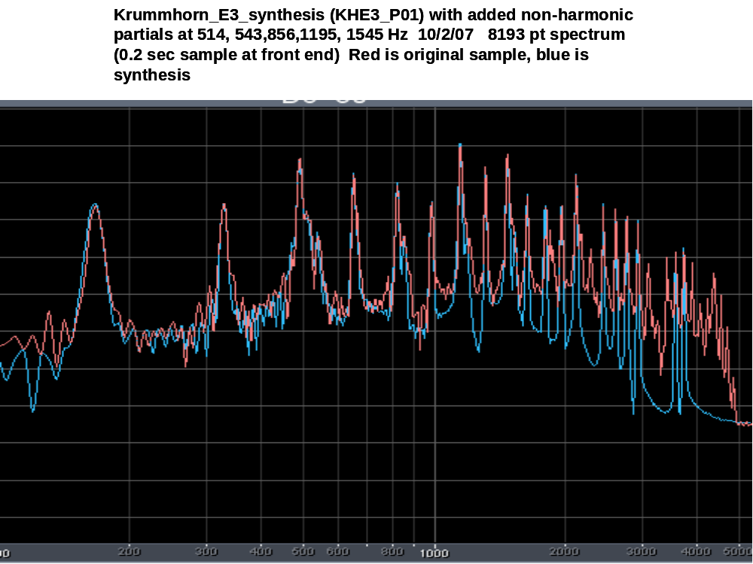

The match between the two spectra is relatively good. This helps support the notion that transient partials may need to be added into the synthesis to capture a good representation of the attack phase; however, it is not a proof because of the liberties I have taken (as previously explained) in the creation of the envelopes of the transient partials and the adjustment of their amplitudes to fit the spectrum measured for the E3 sample.

As noticed in previous experiments where I have added chiff to a flute-like sound, the amplitude of the chiff (and in this case the transient partials) need to be scaled with frequency in order to present a properly sounding effect as the pitch of the note is changed. At frequencies or pitches below that of the reference sound sample, the amplitude of the chiff (transient partial) needs to be raised. At frequencies above the reference sound sample, the amplitude of the chiff or transient partial needs to be lowered. I have found that a simple scaling factor of

(fo/f)^{m}

works well when m = 0.7. This frequency-dependent scaling is in addition to the scaling that is done to moderate the timbre as was previously discussed. The program used to achieve this synthesis is ELAsynthesis_535. This synthesis has the following features:

- Uses compressed envelope data for both harmonic and non-harmonic partials and a compressed time file.
- Uses the measured phase intercepts (or offsets) for each partial. Requires a user-supplied input file called “phase_offsets.txt”.
- Uses calculated frequencies instead of the continuous-phase data files.
- Squashes or time contracts the envelope data to decrease the envelope rise time “R” as the frequency increases. The expression used is equivalent to
R = Ro * (fo/f)^{s} where “s” is presently set to 0.25 and Ro = risetime for the reference note.
5. Scales the amplitude of the transient partials as (fo/f)^{m} , where “m” is a user-set parameter in the configuration file.
6. Moderates the timbre of the notes as (f1/f)^{h * (H-1)} , where “f1” is a user-set parameter in the configuration file (usually set equal to the frequency of the reference note), “f” is the frequency of the note fundamental, “h” is a user-set parameter that is set to1.8 for the Krummhorn example (found by trial and error), and “H” is the harmonic index of the partial being considered. “H” is computed as needed in the program. Here H is allowed to take on non-integer values for the transient partials.
7. Reads a user supplied logical file called “spec_indes.txt” to identify which of the partials are transients and need to be scaled as in (5.) above.
8. Reads a user-supplied file called “amp_mod.txt” to change the amplitude of any partial component by a constant factor. Data in this file are specified in dB relative to 0.0; negative values are used to decrease the amplitude and positive to increase.
9. Reads a user-supplied file called “partial_indicies_real” to specify the non-integer “harmonic” index (or better, partial index) for each partial used.
10. Reads a “notes.txt” file to provide note names for each note group synthesized. These names are easily changed by the “replace” function in any text editor.
11. Reads a configuration file to read in values for:
nsamp number of samples in the compressed envelope and time files
num_partials number of partials used in the synthesis
freq0 freq at which original sample was taken
freq1 ref freq for timbre scaling
scale_param slope of timbre conversion formula (2.42 for Principal pipe, 1.8 for Krummhorn)
spec_scale parameter “m” to set roll off of transient partial amplitude w/freq. Try 0.7.
(usually in range of 0.5 to 0.7)
maxtime number of seconds synthesized. (usually <1.5)
start_note (1 for C1; 7 for C2)
stop_note (31 for C6; 37-C7; 43-C8; 49-C9)
time_f-offset_end (0.0 to avoid this effect,
otherwise 0.4 to 0.5)
bypass (chiff processing bypass 1=yes, 0=no)
chiff_index (partial number that carries chiff)
chiff_end (envelope sample number to stop Modify-chiff ftn, count from 0)
chiff_ref_freq (freq reference used in Modify_chiff ftn)
use high freq to enhance chiff at low end
use low freq if less chiff is needed at low end
chiff_mult freq-independent multiplier for the chiff

I’m not going to explain the parameters after “stop-note” above. I think I have talked about these parameters previously in the description of other synthesis programs. Most of the time set “bypass = 1” and “”time_f_offset_end = 0.0” and then the rest of the parameters are ignored.

This concludes the discussion on the process of organ sound synthesis. Appendices will be added to this document at a later date to discuss the mathematics of the Morlet Wavelet transform and to provide code listings for the programs mentioned in the discussions above.

